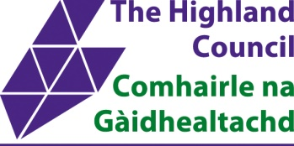

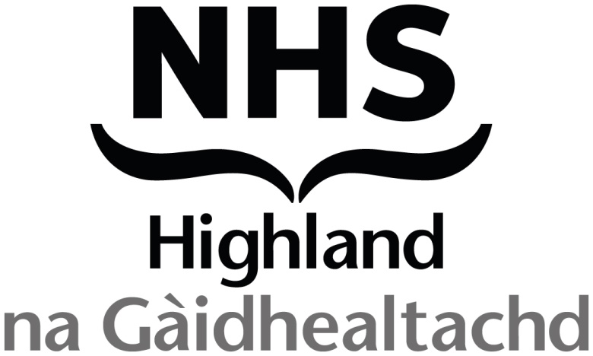

#### MEDIA RELEASE

USE: **Embargoed until midnight 6 November to allow time to communicate with residents, families and staff**

ISSUE DATE: 06 November 2024

**Moss Park Care Home: joint statement from The Highland Council and NHS Highland**

NHS Highland and The Highland Council are delighted to announce that we are progressing work to secure a purchase of the Moss Park Care Home and a transfer of service provision to NHS Highland in 2025.

We also welcome the positive support from the Scottish Government in respect to this intervention which seeks to provide medium term care and certainty for people in Lochaber.

The Highland Council considered a confidential report on the future of Lochaber care provision on 31 October and approved a recommendation to seek to purchase Moss Park Care Home. Both NHS Highland and The Highland Council are pleased to announce that an agreement in principle has now been secured with the current provider.

While this is still only a first step in the process, and there remain a number of complexities to work through, it is hopeful this proposed way forward provides some certainty to care home residents and their families and the care home staff.

A transfer of service provision from HC One to NHS Highland is likely early in 2025. NHS Highland will seek to operate the home in the medium term, until alternative sustainable models of provision in Lochaber can be established in the long term.

We are aware that this has been a worrying time for residents and their families, and for staff and further engagement with stakeholders will take place over the coming weeks. Further information (FAQ) which may help to address any questions will be uploaded to the [NHS Highland website](https://www.nhshighland.scot.nhs.uk/about/highland-health-and-social-care-partnership/moss-park-care-home/) on 7 November.

**ENDS**